**Report 4**

**Progress Made:**

1. Home page is completed. It has three sections namely:
   1. About - This sections contains the information about the ‘Made In India’ initiative.
   2. Products - This section contains 3 different categories of products. The categories are:
      1. Food and Beverages
      2. Electronics
      3. Daily Use Products
   3. Footer section
2. Food and Beverages page is completed. It has 5 categories:
3. Soft Drinks
4. Snacks
5. Ice Creams
6. Biscuits
7. Chocolates
8. Electronics page is completed. It has 8 categories:
9. Solar Products
10. Batteries
11. Mobiles
12. Television
13. LED lights
14. Air Conditioners
15. Headphones
16. Microwave Ovens
17. Daily use products page is completed. It has 7 categories:
18. Toothpaste
19. Soaps
20. Stationary
21. Skincare Products
22. Shampoo
23. Washing Powders
24. Shaving Creams

**Technologies used:**

HTML 5

CSS 3

Bootstrap v4.0

JavaScript for using Bootstrap features

Also link to fontawesome CDN is added which is used for the icon attached in footer section and products section.

**Fonts used:**

These font families are taken from Google fonts

For logo: Font family used is ‘Merienda One’.

For heading in the header: Font family used is ‘Libre Baskerville’.

For section heading: Font family used is ‘Righteous’.

**Snapshot of Home Page**

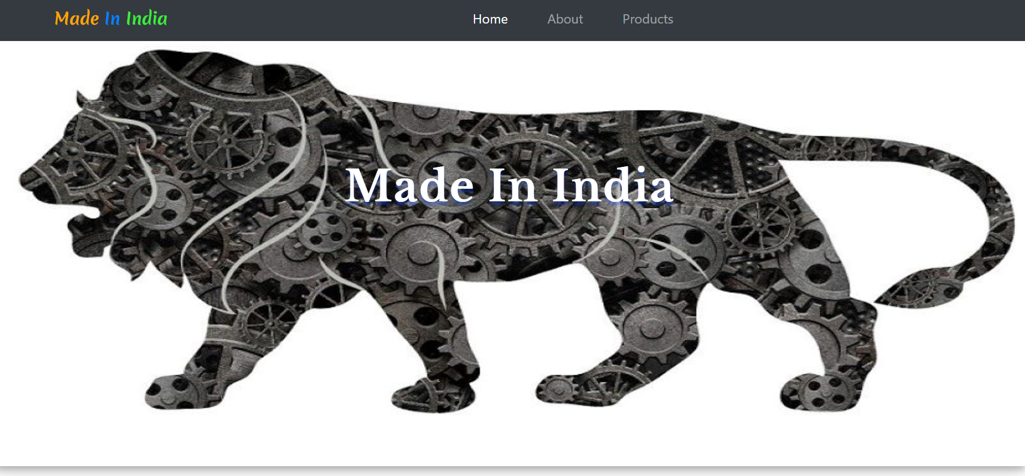

**Snapshot of About Section**

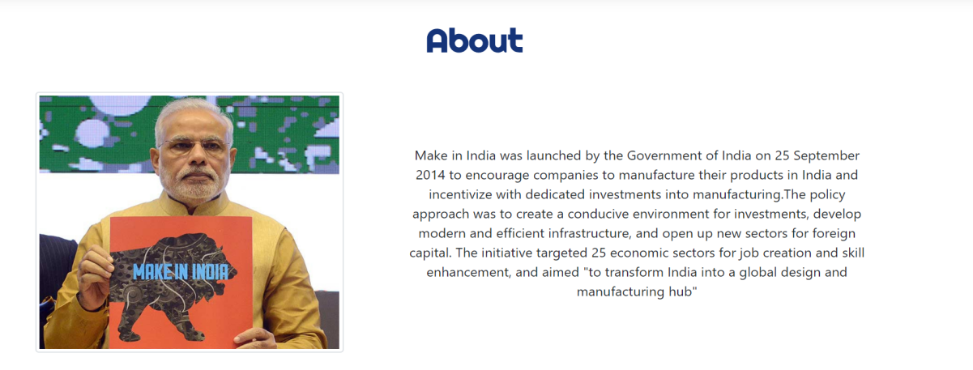

**Snapshot of Products Section**

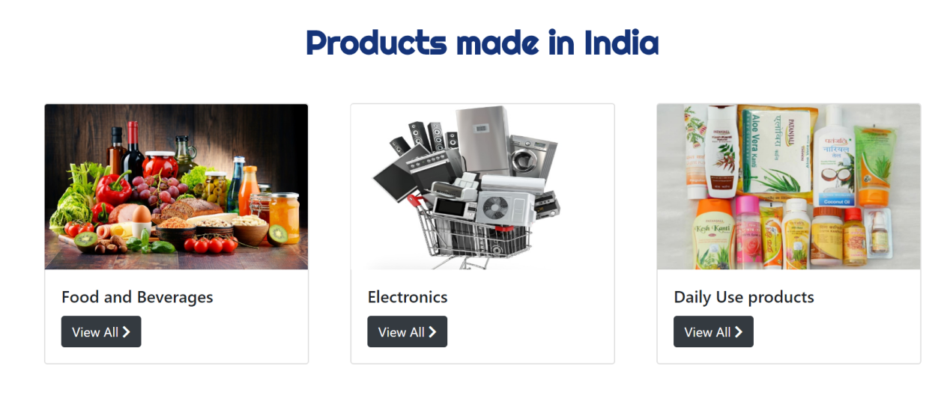

**Snapshot of Footer Section**



**Snapshot of Foods and beverages page**

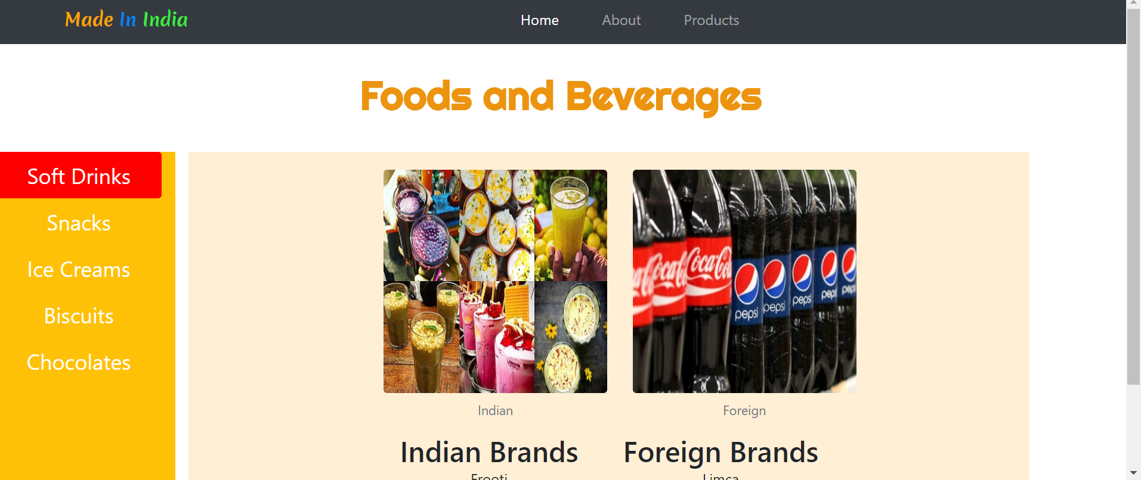

**Snapshot of Electronics page**

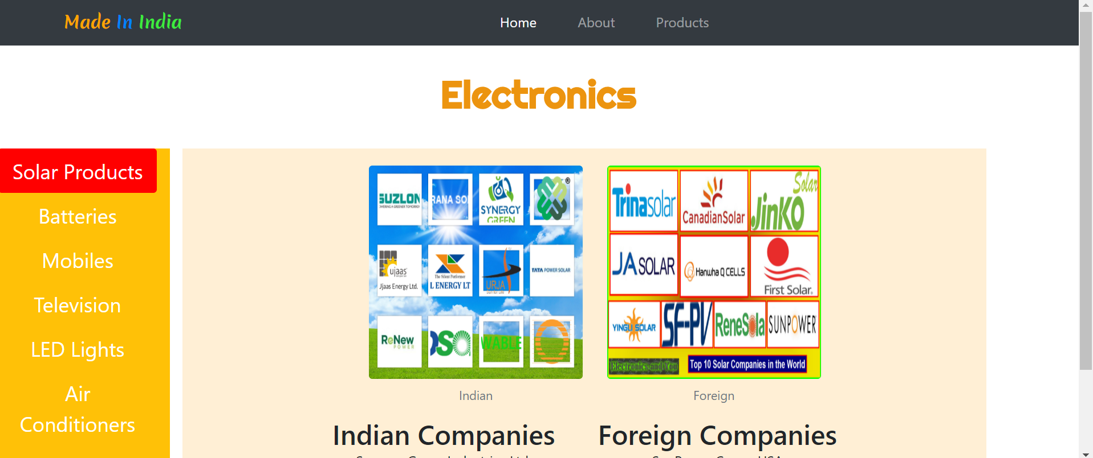

**Snapshot of Daily Use Items page**

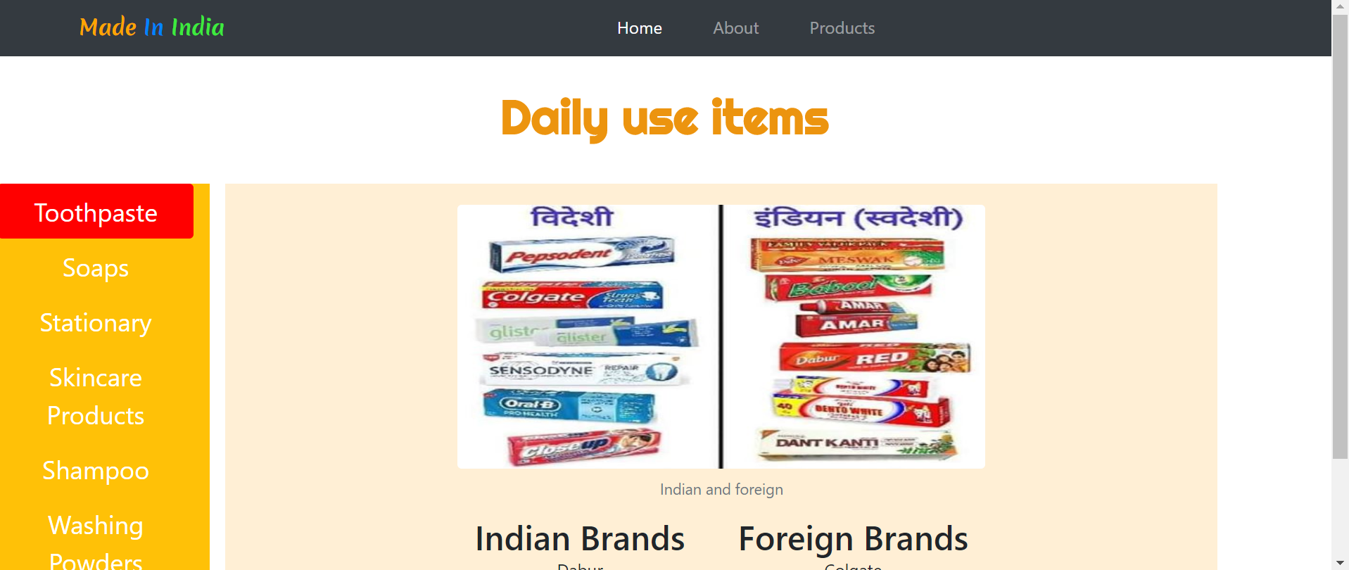

**Image and text Credits:**

About paragraph information taken from Wikipedia.

<https://en.wikipedia.org/wiki/Make_in_India>

About section image credits- <https://www.indiatoday.in/education-today/gk-current-affairs/story/make-in-india-10-indian-brands-at-par-with-foreign-brands-241281-2015-02-20>

**Products section images credits**

food and drinks card image - <https://www.azom.com/article.aspx?ArticleID=18224>

electronics card image- <https://www.business-standard.com/article/companies/indian-electronics-market-to-be-228-bn-in-2020-esdm-117022101200_1.html>

daily use products card image - <https://www.fashionlady.in/best-useful-products-of-patanjali-beauty-for-hair-skin-and-more/109084>

Other images:

Soft drinks - <https://medium.com/@Indian_encyclopedia/indian-beverages-indian-food-cefca2fbd216>

Snacks - <https://www.indiaretailing.com/2019/04/26/food/food-grocery/india-a-growing-market-for-new-flavors-of-snacks/>

foreign soft-drinks - <https://www.behindwoods.com/news-shots/merchants-are-considering-the-boycott-of-foreign-drinks-vikrama-raja.html>

indian-biscuits - <https://www.flickr.com/photos/301202/2112649307>

foreign-snacks - <https://www.amazon.com/Snack-Box-around-world-Package/dp/B01H0X02J8>

indian- chocolate - <https://www.facebook.com/amul.coop/posts/this-extra-dark-chocolate-is-not-for-the-faint-hearted-intense-and-luscious-this/10156995919914446/>

indian-solar - <http://www.electronicsandyou.com/blog/top-10-solar-companies-in-india-listed-in-stock-market.html>

foreign-solar - <http://www.electronicsandyou.com/top-10-solar-companies-in-the-world.html>

toothpaste,skincare,washingpowder - <https://techburner.in/vocal-for-local-list-of-indian-products-vs-foreign-products/>

soaps - <https://officechai.com/stories/pm-modis-focus-self-reliance-prompts-list-made-india-alternatives-foreign-products/>

Presented By:

Aayushi Bansal